淡江大學2024-2025年英語組姊妹校交換生第2次甄選報名表
Tamkang University Exchange Students Application Form (English Group) 2024-2025
個人資料  Personal Information | 中文姓名Chinese name： |  |  | 系所年級班別Department,  Grade, Class
 | 英文姓名(與護照一致)  English name（Same as on the passport）： |  |  | 學 號  Student ID
出生年月日
Date of Birth
YYYY/MM/DD
 | 性 別Gender |  |  | 國籍Nationality
聯 絡  資 料  Contact Details | 手機號碼Cellphone number：  家裡聯絡電話Home number.：  E-mail（須經常保持有效收件Needs to be used very often）：
志願順序選填  University Options  請在內填1.2.  3…志願順序)  Fill in 1.2.3…in the order of priorities | 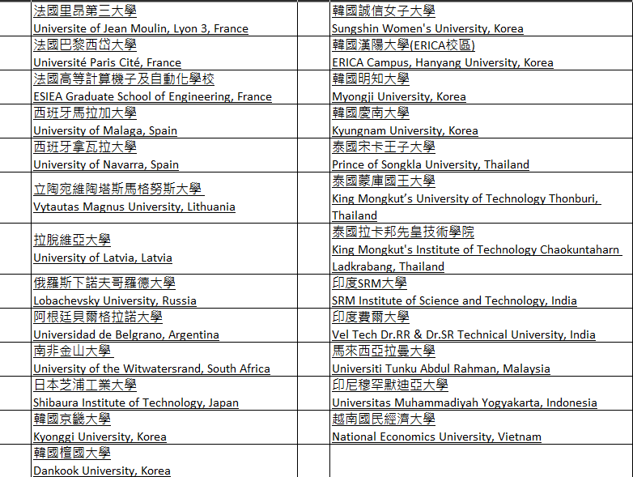
個資保護聲明與簽署Personal Data  Protection Statement |  | - 茲同意貴處引用本人申請表列個資，供交換生甄選及薦送作業之用。承辦單位依據個資保護法，對申請者所提供之個人資料，只會作適當且相關的處理，並會依法或在合法的特定目的及保存期限下保存。詳細個資聲明請閱http://www.tku.edu.tw/pdp.asp  I hereby agree to provide my personal information for exchange student selection and inspection operations. The organizer will act in accordance to the personal data protection act and use the following information for these specific purposes. The information will be preserved under the law or for legal purposes. For more details on personal information statements, please read http://www.tku.edu.tw/pdp.asp
申請人簽章
Applicant Signature
附 註  Notes |  | 請謹慎填寫姊妹校志願及順序，一經公告錄取後，不得變更。請先上網閱覽及瞭解各姊妹校校況、院系所課程等資。  Please take careful consideration when completing the University Options for Wish List. Once accepted, there are no alterations. Please read and understand the information of each sister school, department and course detail.

